1. Output: 

Source code:

#include <stdio.h>

int main() {

char phoneInput[13];

char phoneRes[12];

int i = 1;

printf("Enter Phone Number - [(999)999-9999]:\n");

scanf("%s", phoneInput);

for (i = 1; i < 13; i++) {

if (i == 4) {

phoneRes[i - 1] = '-';

}

else {

phoneRes[i - 1] = phoneInput[i];

}

}

printf("You entered %s\n", phoneRes);

return 0;

}

2. Output

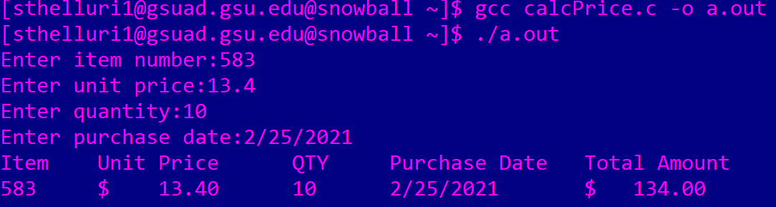

Source code:

#include <stdio.h>

int main(){

int item;

double price;

int quantity;

char date[10];

printf("Enter item number:");

scanf("%d", &item);

printf("Enter unit price:");

scanf("%lf", &price);

printf("Enter quantity:");

scanf("%d", &quantity);

printf("Enter purchase date:");

scanf("%s", date);

double total = price \* quantity;

printf("Item\tUnit Price\tQTY\tPurchase Date\tTotal Amount\n");

printf("%d\t$%9.2lf\t%d\t%s\t$%9.2lf\n\n", item, price, quantity, date, total);

return 0;

}